# Project1IWT

# Created on August 02 2019

# Table of Contents

1.0. Registration Page

2.0. User Account Page

3.0. Admin Page

# 1.0. Registration Page

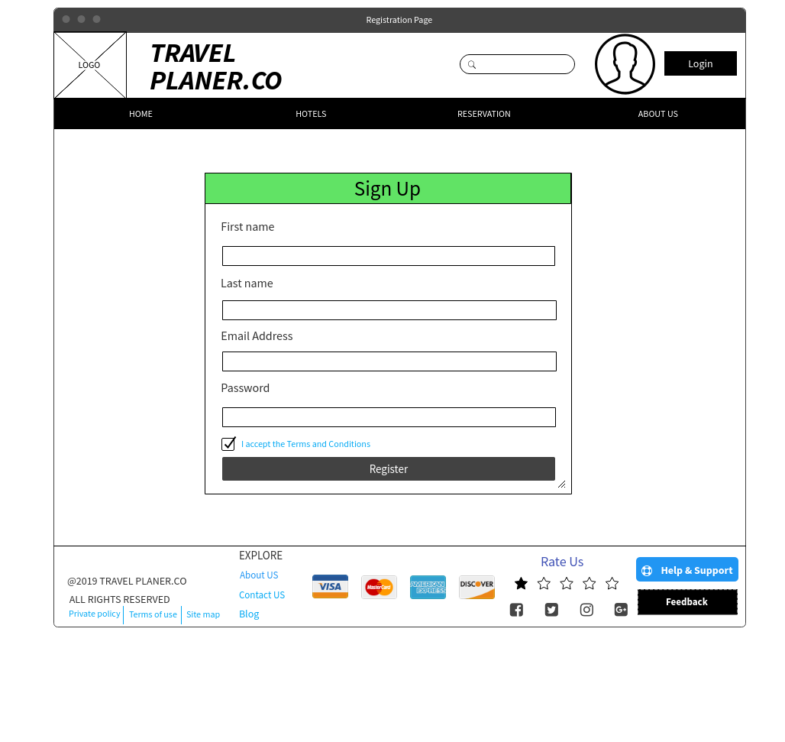

# 2.0. User Account Page

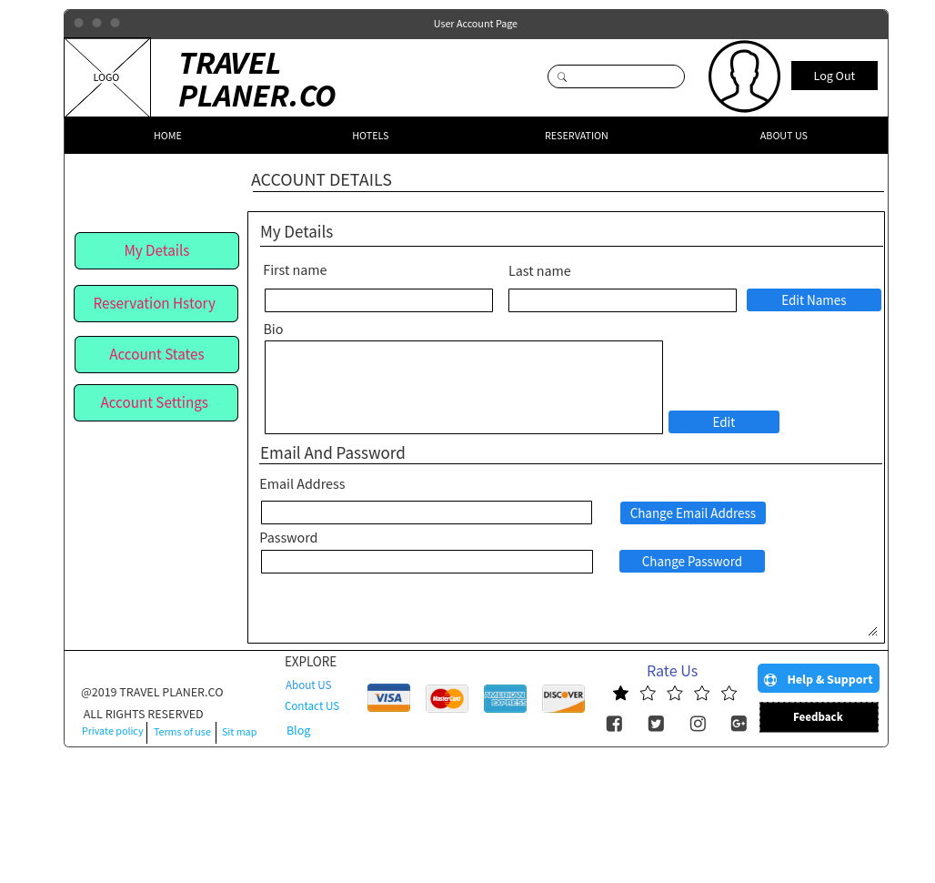

# 3.0. Admin Page

